#define LED_PIN 8
#define BUTTON_PIN 7

void setup() {
pinMode(LED_PIN, OUTPUT);
pinMode(BUTTON_PIN, INPUT);
}

void loop() {
if (digitalRead(BUTTON_PIN) == HIGH) {
digitalWrite(LED_PIN, HIGH);
} else {
digitalWrite(LED_PIN, LOW);
}
}
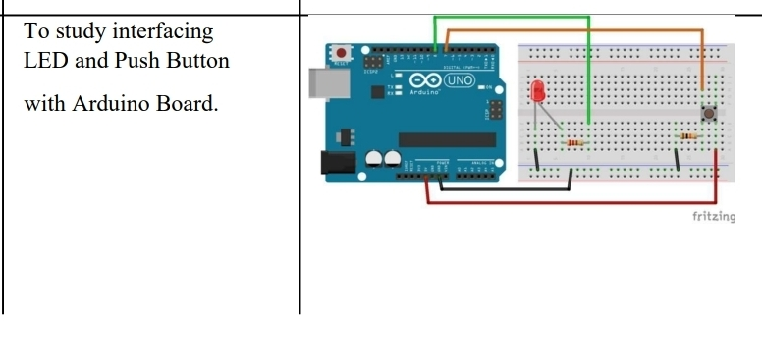

- LED TOGGLE USING BUTTON
#define LED_PIN 8
#define BUTTON_PIN 7

byte lastButtonState = LOW;
byte ledState = LOW;

void setup() {
pinMode(LED_PIN, OUTPUT);
pinMode(BUTTON_PIN, INPUT);
}

void loop() {
byte buttonState = digitalRead(BUTTON_PIN);

if (buttonState != lastButtonState) {
lastButtonState = buttonState;

if (buttonState == LOW) {
ledState = (ledState == HIGH) ? LOW : HIGH;
digitalWrite(LED_PIN, ledState);
}
}
}

- LED WITH DEBOUNCE
#define LED_PIN 8
#define BUTTON_PIN 7

byte lastButtonState = LOW;
byte ledState = LOW;

unsigned long debounceDuration = 50;
unsigned long lastTimeButtonStateChanged = 0;

void setup() {
pinMode(LED_PIN, OUTPUT);
pinMode(BUTTON_PIN, INPUT);
}

void loop() {
if (millis() - lastTimeButtonStateChanged > debounceDuration) {

byte buttonState = digitalRead(BUTTON_PIN);

if (buttonState != lastButtonState) {
lastTimeButtonStateChanged = millis();
lastButtonState = buttonState;

if (buttonState == LOW) {
ledState = (ledState == HIGH) ? LOW : HIGH;
digitalWrite(LED_PIN, ledState);
}
}
}
}

